**Lab 9: DB CONNECTIVITY WITH WINDOWS FORM CRUD APP**

**Step 1:**

Open Visual Studio > File > New > Click **Project.**

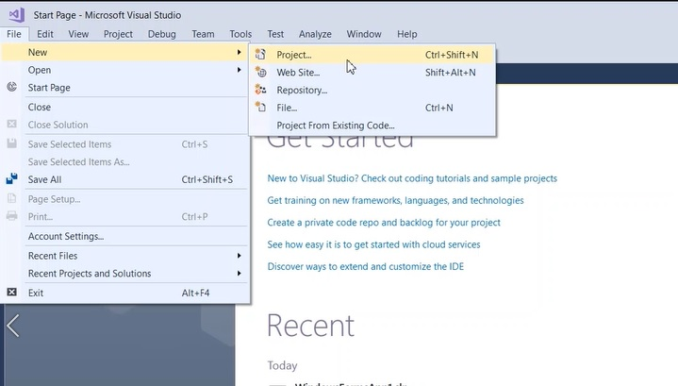

**Step 2:**

In New Project dialog, Select Visual C# templates > Choose .Net Framwork > Select "Windown Forms App (.Net Framework)"

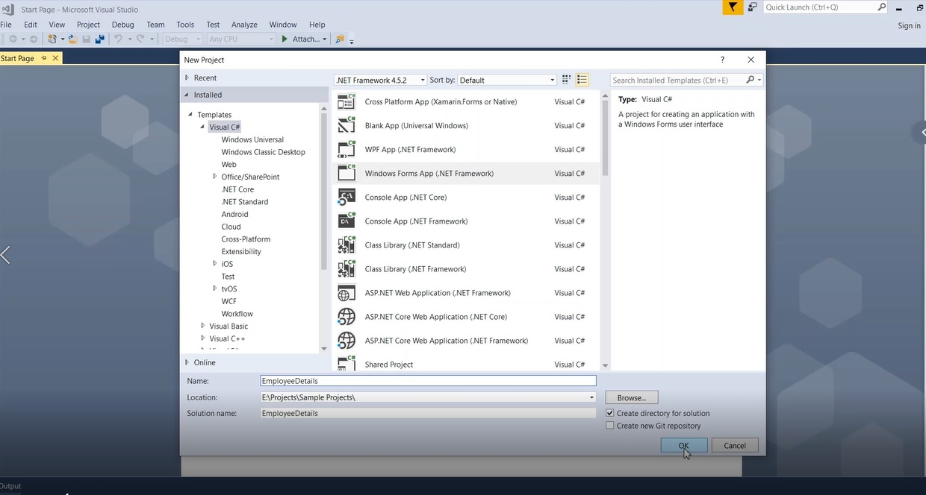

**Step 3:**

Once the application created successfully, We will start adding controls from the **Toolbox** section as shown below and provide proper naming for controls.

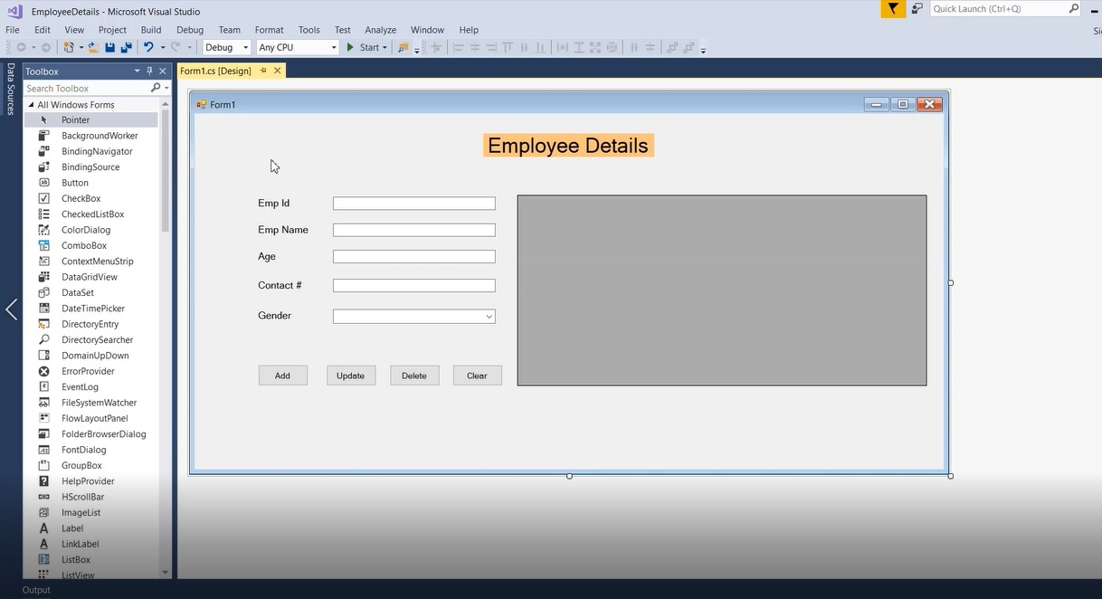

**Step 4:**

Next, We will create a database and table in SQL Server. Open "Microsoft SQL Server Management Studio" > Right Click "**Database**" folder > Click "New Database".

The below "New Database" dialog, provide a new database name as "**dbEmployeeDetails**" and click **OK.**

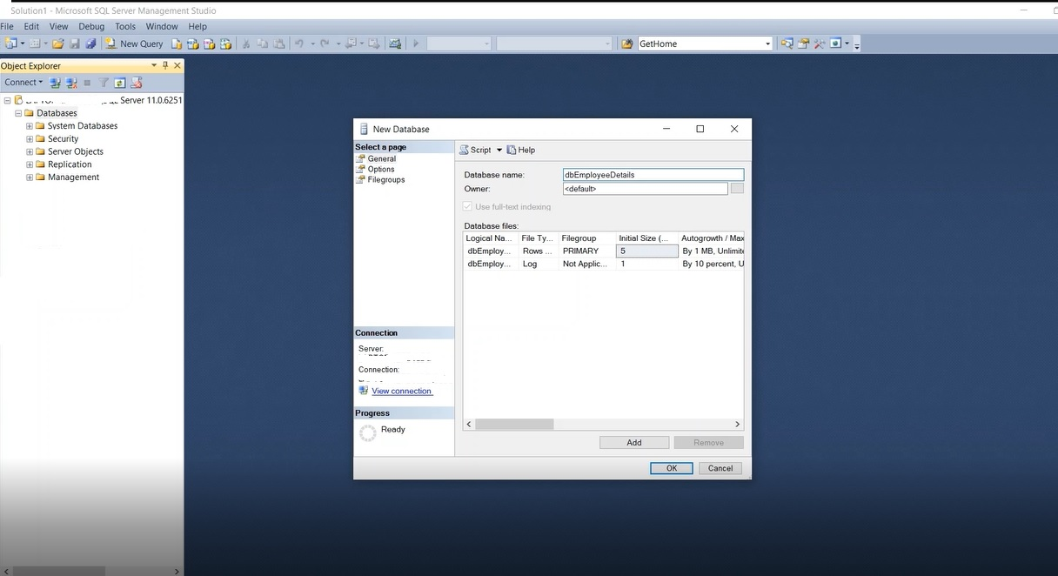

**Step 5:**

Run below new table creation query in SQL window to create a new Emp_details table.

CREATE TABLE [dbo].[Emp_details](

[EmpId] [int] NOT NULL,

[EmpName] [nvarchar](50) NULL,

[EmpAge] [int] NULL,

[EmpContact] [int] NULL,

[EmpGender] [nchar](10) NULL

)

You can also verify table columns by Right Click newly created table and click "Design". The table looks like below in SQL studio,

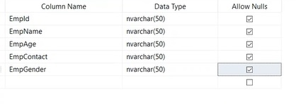

**Step 1:**

How to connect database from Windows application?

We will add database connection easily in windows application in simple steps as shown below,

Go to Tools menu > Click "Connect to Database".

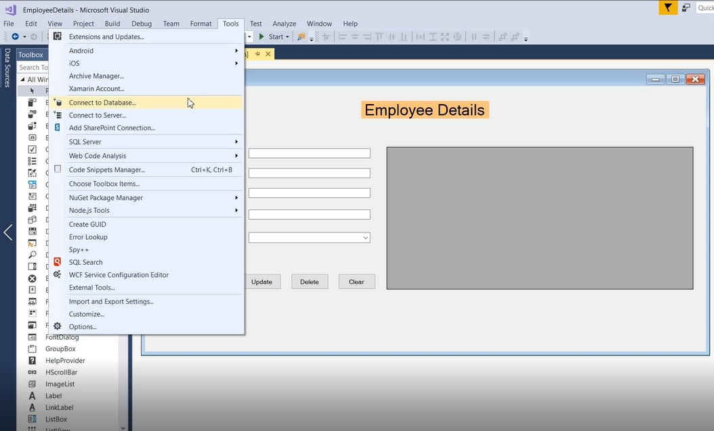

**Step 2:**

By default, the data source is selected as Microsoft SQL Server (SQL Client).

Provide "Server name" to . or localhost. and Select our database in the dropdown as "dbEmployeeDetails"

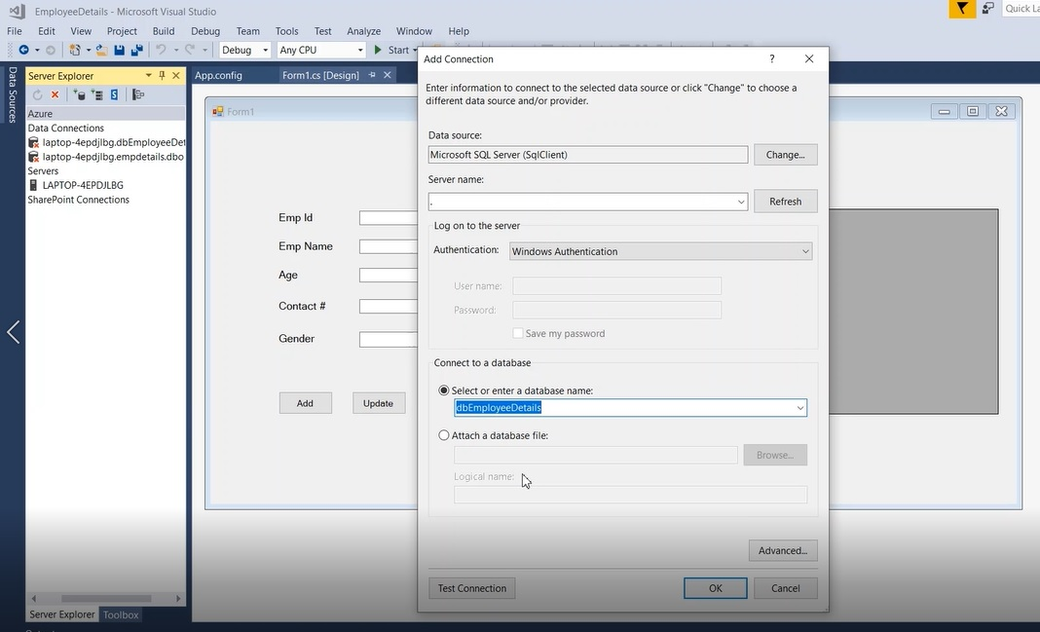

**Step 3:**

We need to verify the database connection by clicking the "Test Connection" button as shown below, Once the connection is verified you will see the "**Test connection succeeded**" message box.

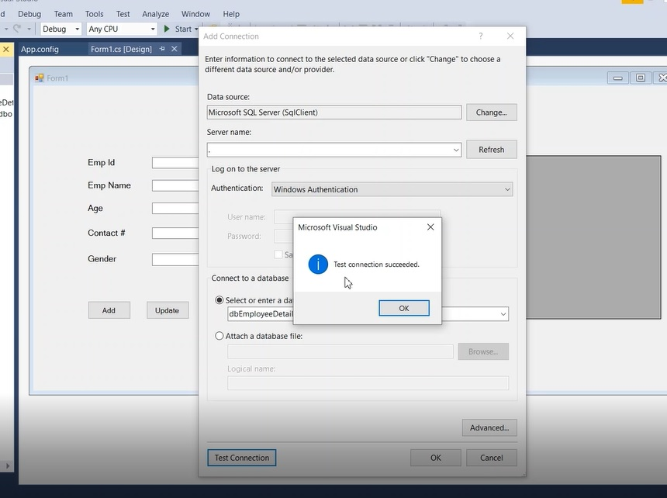

**Step 4:**

Once the database connection is created, then you will see the connection details as shown below,

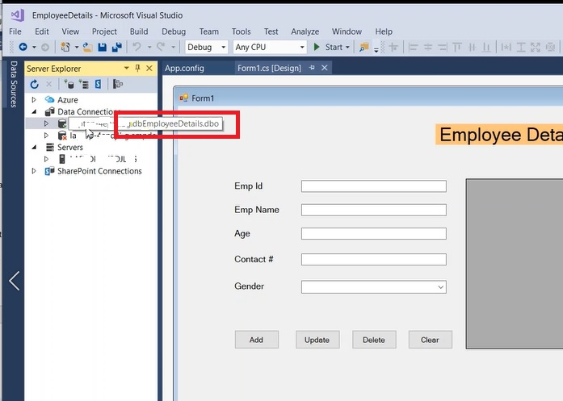

**Step 5:**

How do I know the connection string?

Right Click database connection > Properties > Copy "Connection string" for our reference as shown below,

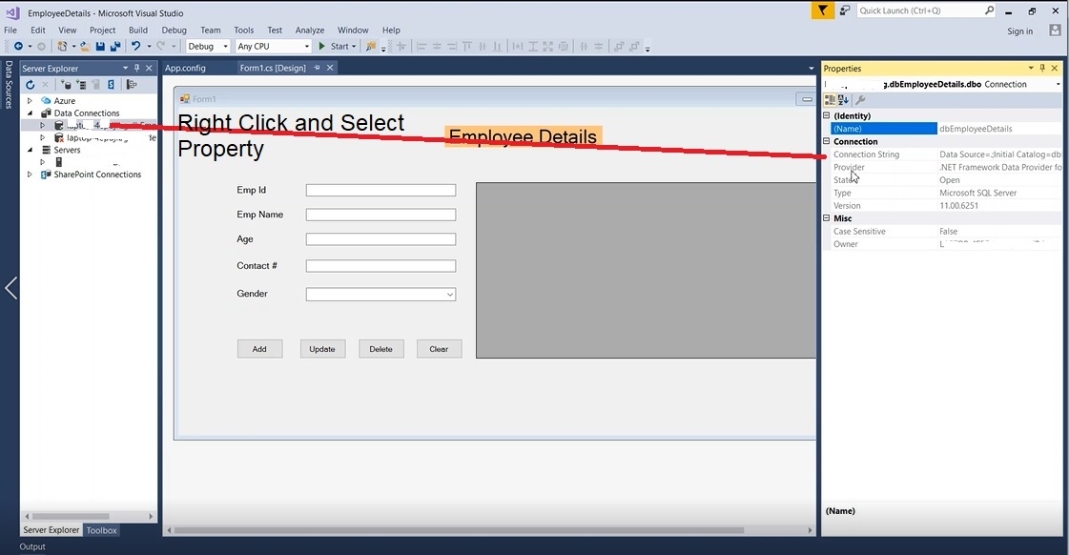

**Output:**

Add employee details and Click "Add" button,

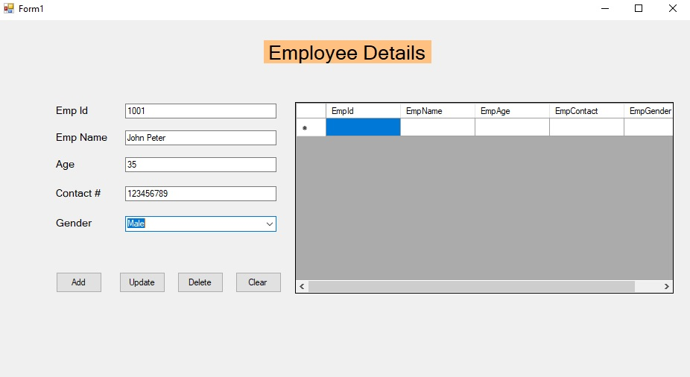

The employee details are successfully inserted.

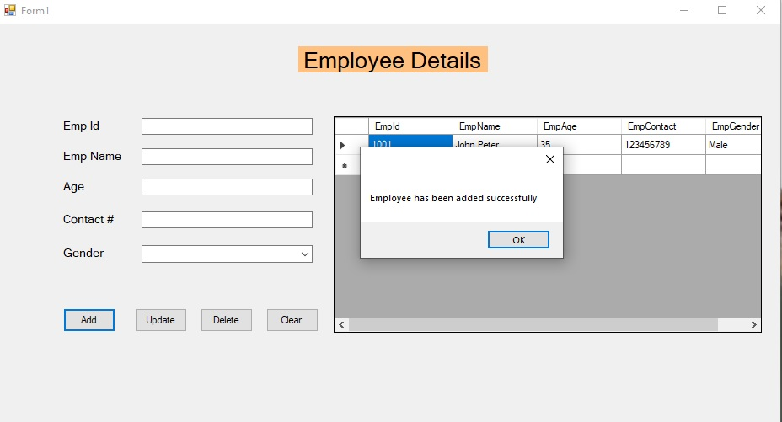

When you select the grid row (employee)  selected employee details will be populated in the controls for Update or Delete purpose

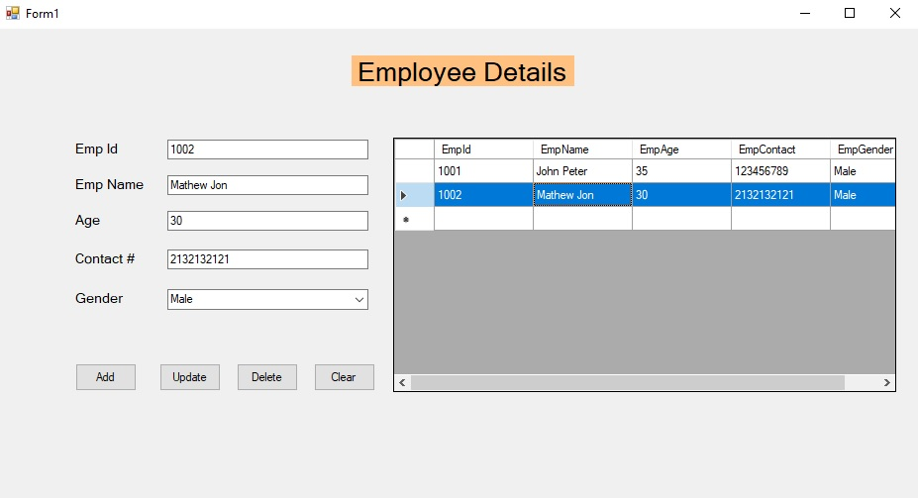

TASK:

Create a CRUD windows form application for students data using “One procedure for all CRUD operations” (use IF Else concept )

Note: Project is uploaded in miscellaneous section

**GetData Procedure:**

CREATE PROCEDURE GetData

AS

BEGIN

SET NOCOUNT ON;

SELECT *

FROM emp;

END

**InsertData Procedure:**

CREATE PROCEDURE InsertData

@name varchar(50),

@address varchar(50),

@dept varchar(50)

AS

BEGIN

INSERT INTO emp (name,address, department)

VALUES (@name, @address,@dept);

END

**UpdateData Procedure:**

CREATE PROCEDURE UpdateData

@id int,

@name varchar(50),

@address varchar(50),

@dept varchar(50)

AS

BEGIN

UPDATE emp

SET name = @name,

address= @address,

department=@dept

WHERE id=@id;

END